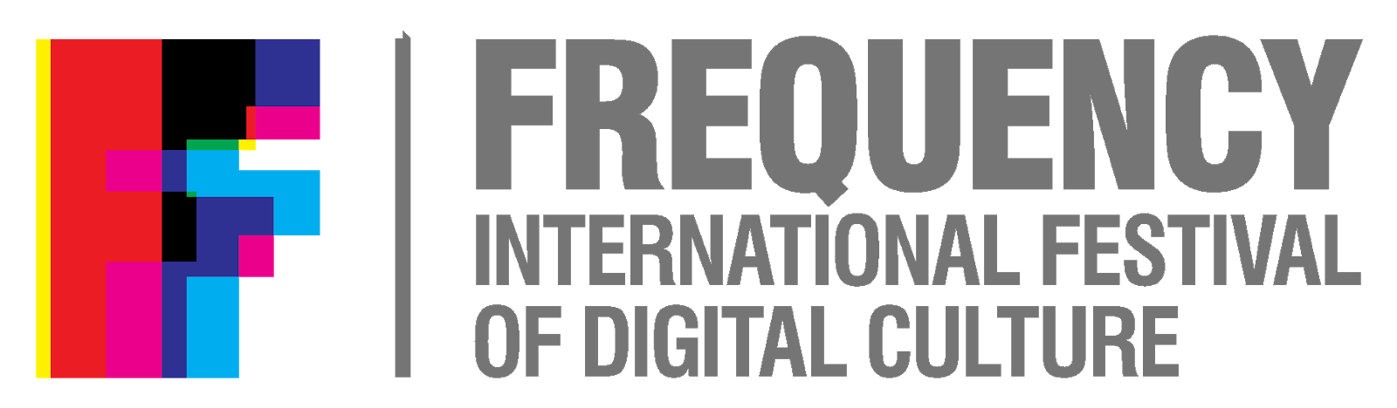
Job Description:
Frequency 2021 Event Producer
Contract:
Fee: £10,000 inclusive of VAT and all costs (with the exception of accommodation and travel to be agreed)
Engagement: Fixed Term Freelance Contract
Term: 19th July – 5th November 2021
Flexible with the expectation of working full time for the last 2 weeks of Oct and first week of November.
About the Role:
Threshold is seeking an experienced Event Producer to lead on the delivery of Frequency International Festival of Digital Culture in Lincoln in Oct 2021. You will be responsible for ensuring all the works are installed to high specifications, considering the creative aspiration balanced with audience needs as well as the restrictions around H & S / Covid Guidance and audience safety.
With a strong track record of delivery, you will be resourceful, a self-starter, able to get the best out of people from a range of backgrounds (from stakeholders to graduate interns). You will need to work to tight deadlines and be solution-focussed.
You will be responsible for a small production team as well as the Frequency hosts (volunteer stewards mainly recruited from the University of Lincoln)
Context for 2021:
This edition of Frequency comes at a time of lockdown easing across the UK. Staged over 4 days between 28th - 31st October 2021, the festival will comply to national and local Covid safety guidance, building the local capacity for major events in the city as a test event
In a year of reduced restrictions, but also in anticipation of the unknown, the festival will have to programme responsively. What is known is that all work will be outdoors for the 2021 edition. The programme will explore experimentation with the built environment and focus on an online and physical experience creating a blended experience for Frequency 2021.
Pre-Production workflow will assume the majority of the team working in a remote capacity with the collective Festival team coming together in Mid October.

Principle Relations
Reports to: Director of Programmes
Management responsibilities: Technical Manager, Events Assistant, Graduate Production Intern (Production Assistant), Festival Hosts (Volunteer Stewards)
Working with: Threshold Management team, Local Authority Officials, Lincoln BIG, Emergency Services and SAG, University of Lincoln, Participating sites and venues, Frequency 21 family of artists and communities.

Person Specification

Criteria | Essential/  Desirable
Experience:
Relevant industry experience in live and public events, ideally within culture and multi-arts programming | Essential
Ability to build relationships, with speed, integrity and credibility, with a diverse range of people (internal and external). | Essential
Multi stakeholder management including HEI, Local Authority, BID and wider partners | Desirable
Negotiation with suppliers in order to deliver on time and on budget | Essential
Proven effective communication skills and problem-solving abilities. | Essential
Demonstrable experience leading in a Senior role within a creative project team | Desirable
Track record of Artist liaison, overseeing booking, travel and welcome during setup and live period. | Essential
Management of live events from pre-production to live period to take down. | Essential
Working in cultural events with a democratic digital focus | Desirable
Ensuring all legal and contractual obligations are met | Essential

Person Specification (continued)

Skills:
Track record of working with Technical management and to plan installs and opening of installations and events, including collation of technical specs, adaptation to spaces and H and S Compliance | Essential
Exceptional planning, co-ordination and project management skills | Essential
Ability to mentor and coach on the job training to graduates and volunteers | Desirable
Astute Budget management and reporting | Essential
Good working knowledge of digital technologies | Desirable
Ability to work well under pressure and supporting teams | Essential

Application process:

Please supply the following:
- A written submission in support of your application, ensuring you respond to the Person Specification, and no more than 3 sides of a4.
- An up-to-date CV including 2 appropriate referees

Timeline
- Deadline for applications: 2nd July submitted by email to sam@thresholdstudios.tv
- Interview dates: 7th and 8th July

Additional Information:

About Threshold:
Directors of Frequency Festival, Threshold is a creative and cultural agency using digital technology to create space for change, an Arts Council England NPO, we nurture creativity, seek out new diverse talent and deliver transformative experiences so that people and places can thrive.
www.thresholdstudios.tv

About Frequency:

Frequency is…in favour of seeing digital as pure medium rather than something to be feared: we see the confluence of human and tech as a bringer of community and as an adjunct to life that has the potential to be beautiful.”
Eye on Design

“This spectacular, world-class festival shows how different industries and talents across art, culture and digital technologies can work together.”
Visit Lincoln
Frequency International festival of Digital Culture is hosted biennially in the historic city of Lincoln. Since its inception in 2011, Frequency has become renowned for city-wide digital takeovers in non-traditional spaces, including exhibitions of site-specific work, live performances, world premieres, and interactive experiences open to all. Frequency has hosted over 500 place-based, national and international artists, exhibiting their work to over 75,000 visitors across four festival editions. Frequency draws the city’s residents and its visitors off their intended path to discover a world of digital, electronic and hybrid art in unusual spaces; mainly the city’s heritage spaces and its shopping precincts, and into its venues, museums and galleries.
Frequency Festival is produced by Threshold Studios, in partnership with the University of Lincoln and supported using public funding by Arts Council England. The event is driven by a dynamic city wide collaboration of public sector organisations, along with support from the business community.
www.frequency.org.uk
